Module name :Testing shopping application and identifying
actual defects.
Test case ID:ST_01
Webpage URL:www.amazon.com

Scenario ID : 1a

Scenario:Login
Test steps:

(1)enter username.
(2)enter password.
(3)click on continue

Screenshot:

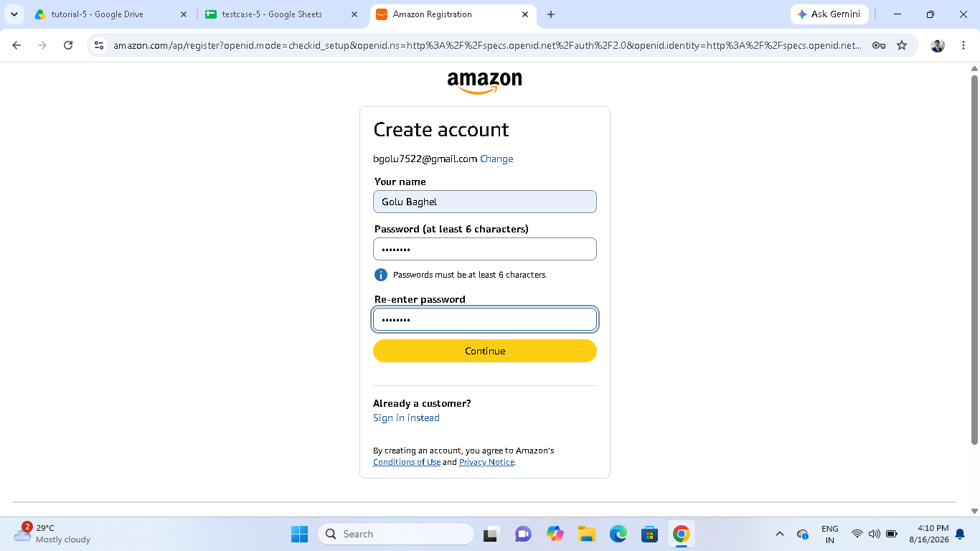

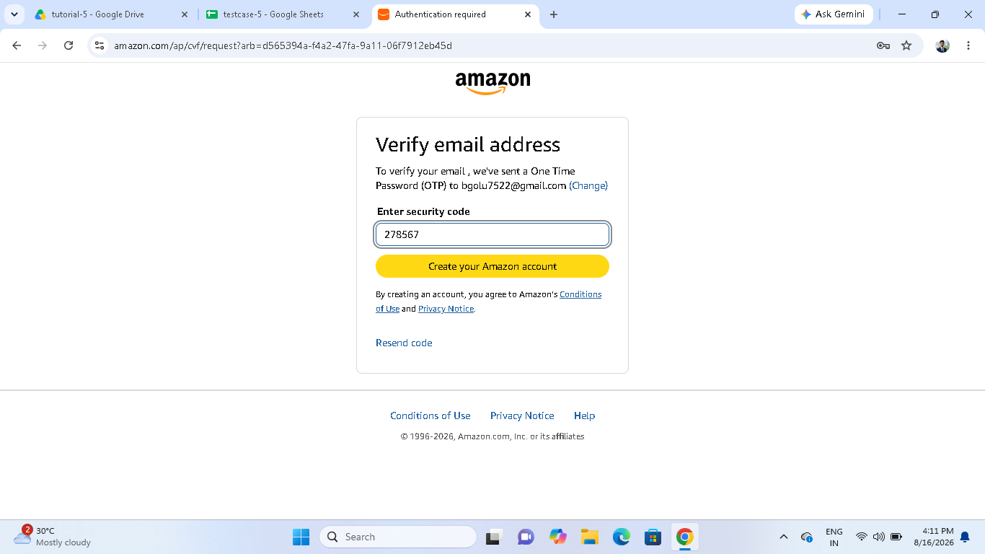

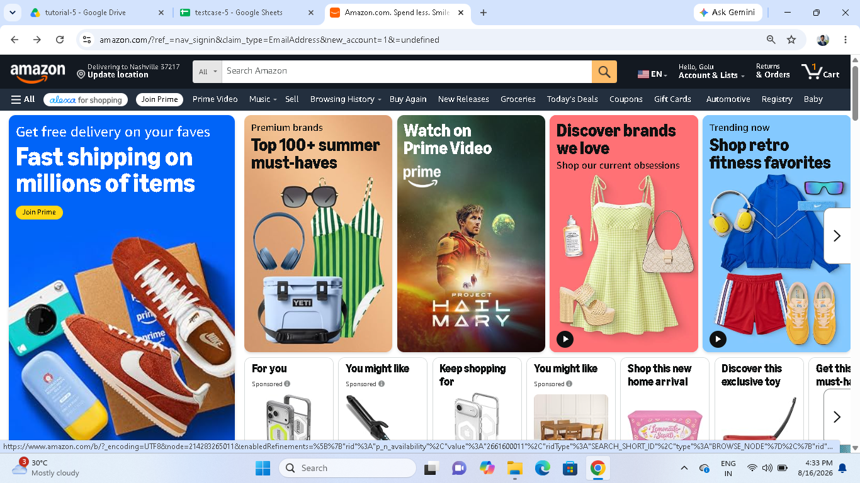

Scenario ID : 1b

Scenario: Invalid login
Test steps:

(1)enter invalid username.
(2)enter invalid password.
(3)click on log-in.

Screenshot:

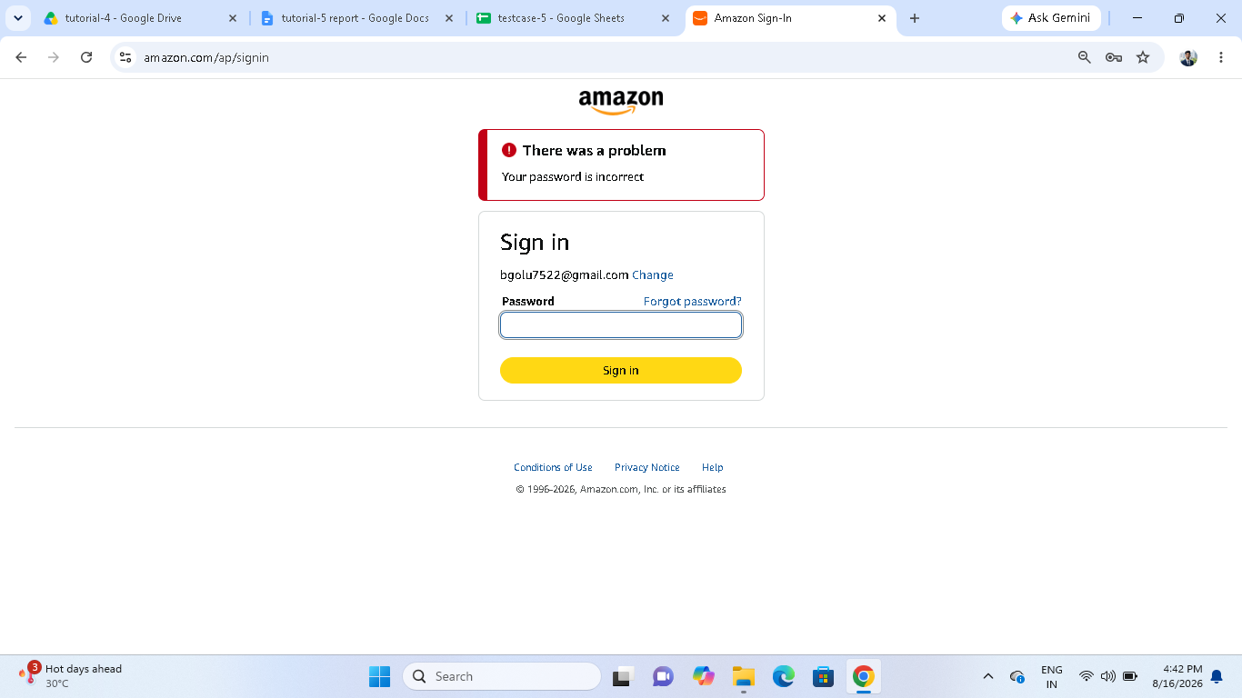

Scenario ID : 1c

Scenario: Product display.

Test steps:

(1)click on product then you can
see products

Screenshot:
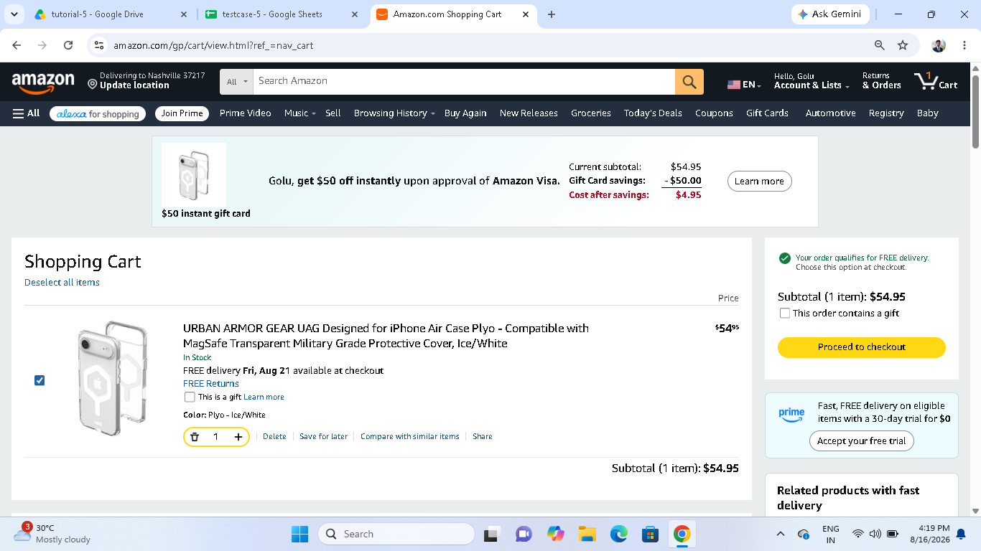

Scenario ID : 1d

Scenario: Add to cart

Test steps:
(1)click on product.
(2)click on add to cart button.

Screenshot:

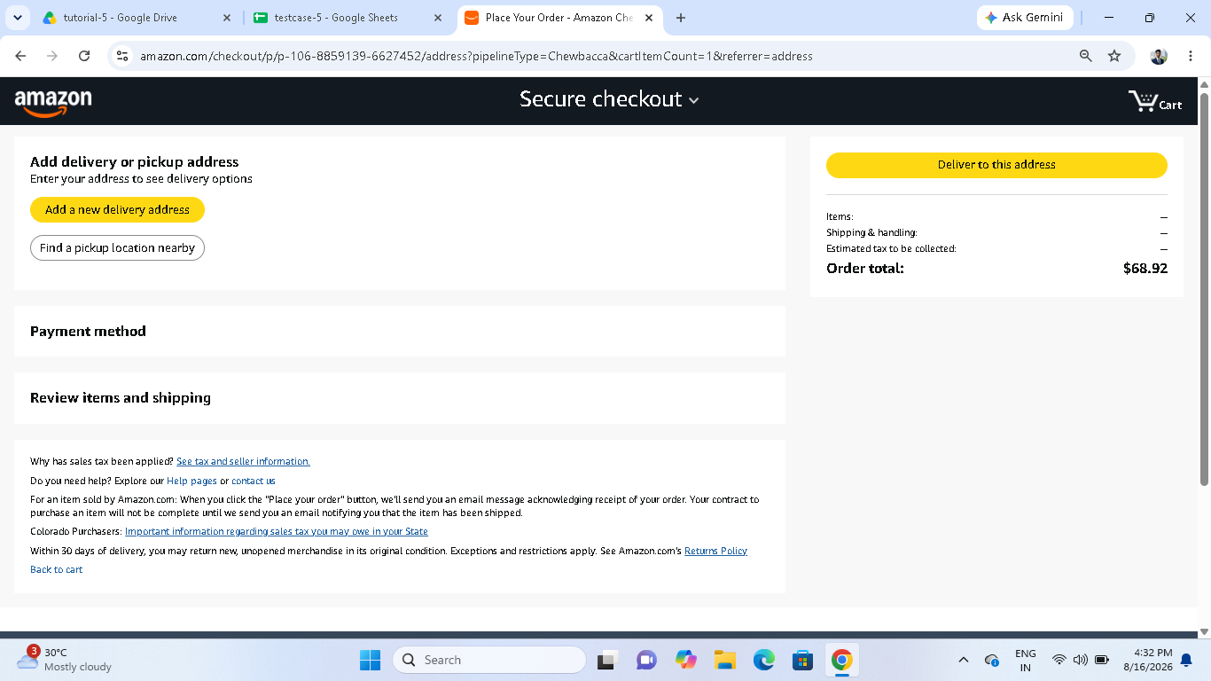

Scenario ID : 1e

Scenario: Remove from cart

Test steps:
(1)select a product
(2)click on cart button.
(3)press on delete button

Screenshot:

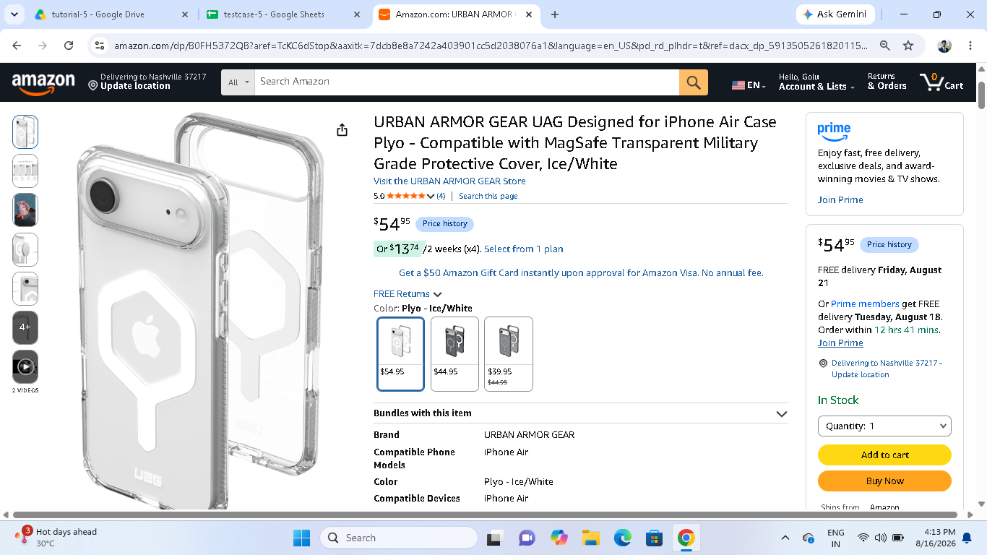

Scenario ID : 2a

Scenario: Check-out

Test steps:
(1)select a product.
(2)click on checkout button.

Screenshot:

Scenario ID : 2b

Scenario: Log-out

Test steps:
(1)click on log-out button

Screenshot:

